John-Joshua Izuebu

Prof. Susan Miertschin

CIS 4338

April 2, 2021

* Task 1
  + 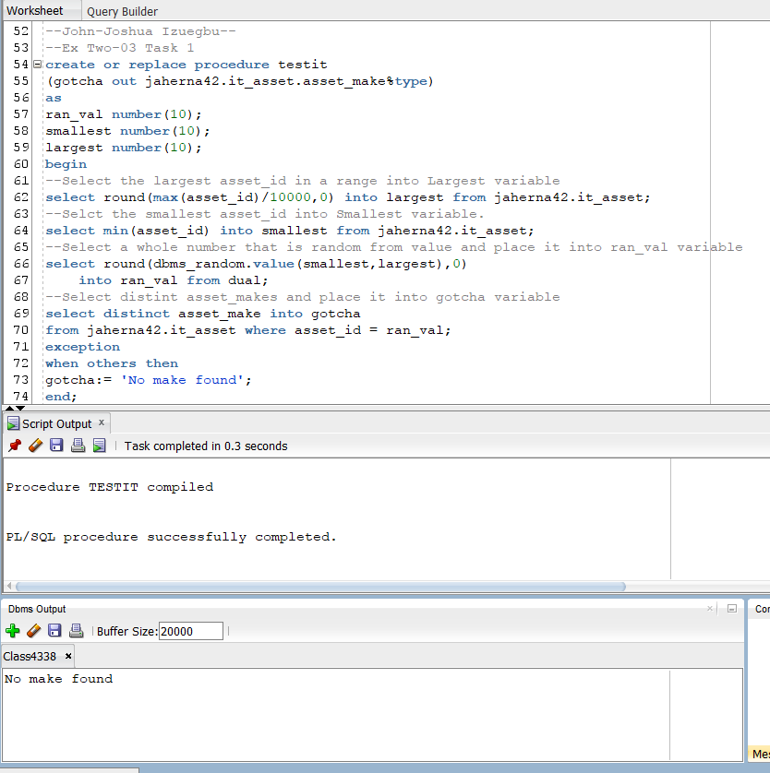
    - Run the procedure to see if I have privileges, and run the DBMS to see the response.
* Task 2
  + 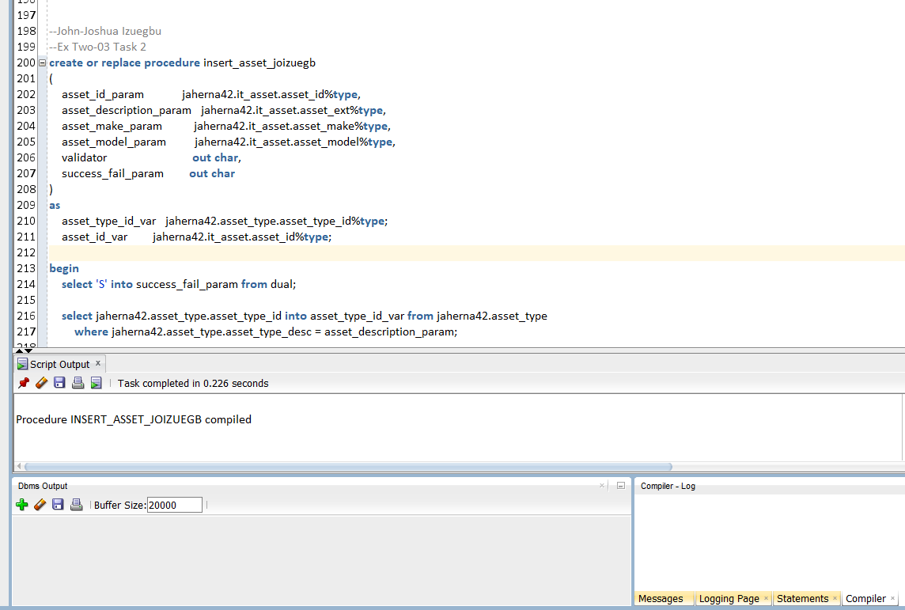
* Task 3
  + 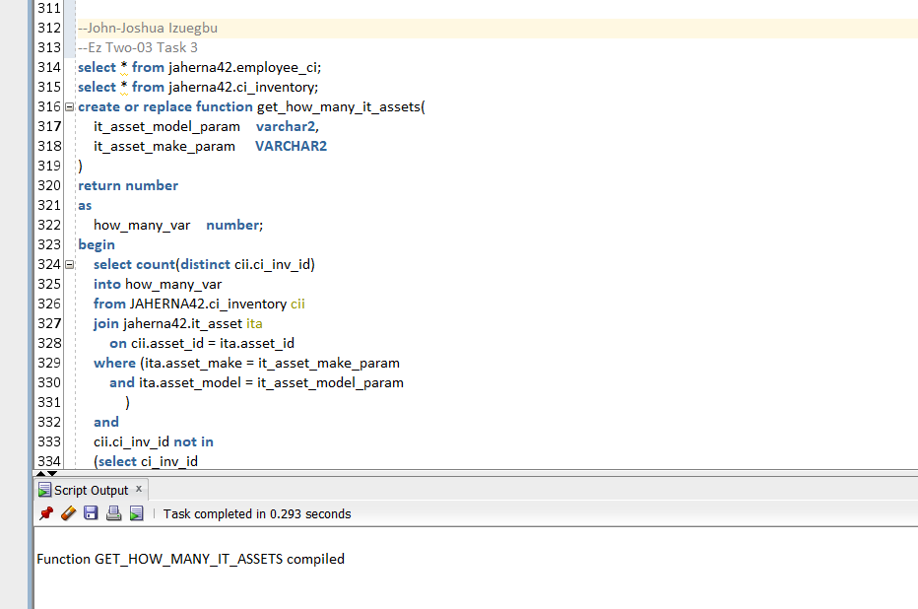
* Task 4
  + 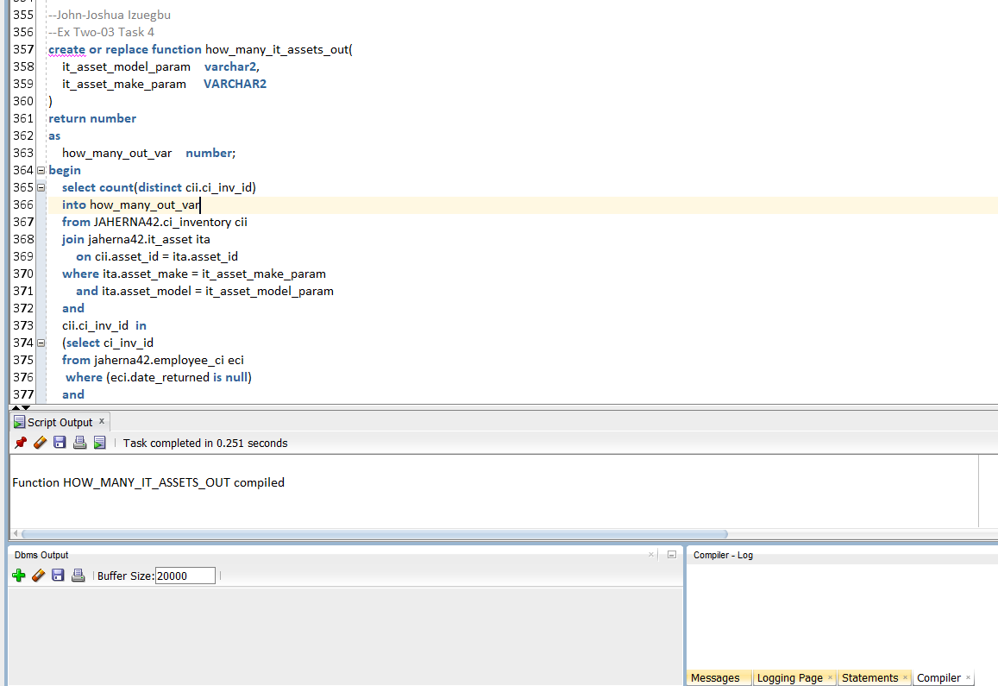
* Task 5
  + 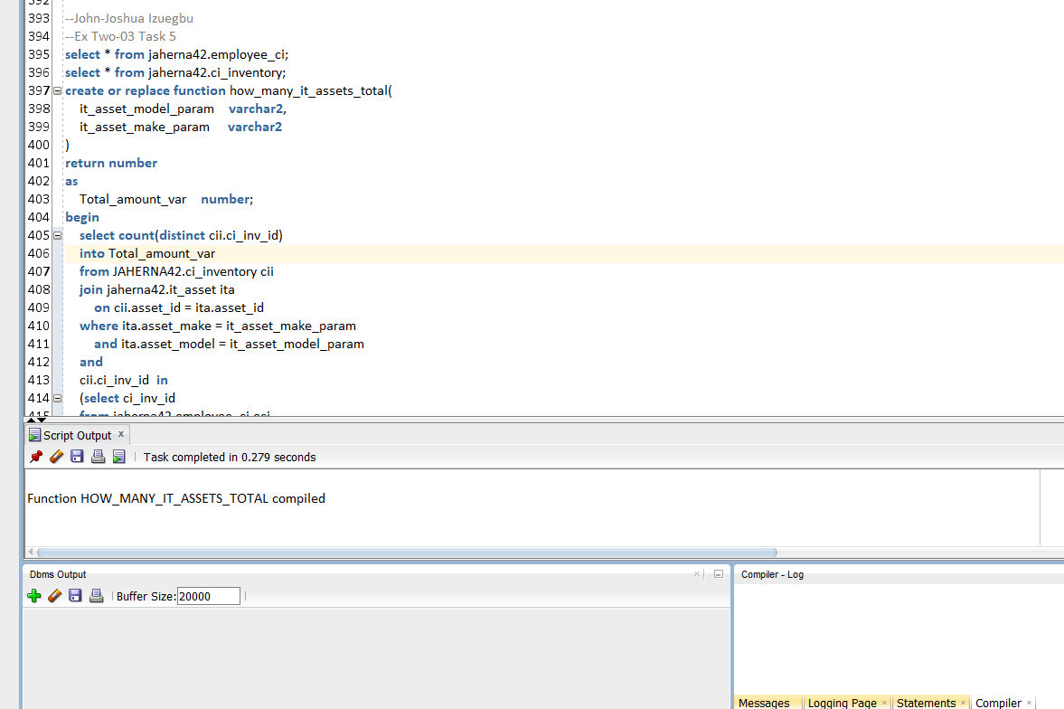
* Task 6
  + 